Odata SEGW projects for Github API's

Monday, April 17, 2023

5:56 PM

OData services Examples

Tuesday, April 18, 2023

12:49 AM

When ever change in entity types - make sure load the metadata again

Odata get expanded entity set example:

<https://blogs.sap.com/2020/01/08/get-expanded-entity-set-get-expanded-entity-sap-odata/>

Example:

***URI :*** /sap/opu/odata/sap/ZDEEPSTRUCTURES_SRV/HeaderSet?$expand=HeaderToItemNav

*<*[*https://blogs.sap.com/2020/01/08/get-expanded-entity-set-get-expanded-entity-sap-odata/*](https://blogs.sap.com/2020/01/08/get-expanded-entity-set-get-expanded-entity-sap-odata/)*>*

T46 :

/sap/opu/odata/SAP/Z_CCS_GITHUB_FILES_SRV/GitrepoSet?$expand=GitrepoToTree

Below API is getting called for the odata service : Z_CCS_GITHUB_FILES_SRV

API to fetch all the folders and files inside folders for a given repository

<https://api.github.com/repos/Devsouravpanda/Sample/git/trees/main?recursive=1>

Odata Filter option example:

<http://www.techippo.com/2016/08/filter-query-option-sap-odata.html>

T46:

/sap/opu/odata/SAP/Z_CCS_GITHUB_FILES_SRV/GitcommitSet?$filter=Date eq '20230912'

To get roles for a given userid from system

/sap/opu/odata/SAP/Z_CCS_ROLES_SRV/RolesSet?$filter=User eq 'TRNGAB98'

 T46/022 - SEGW : Project name : Z_CCS_GITHUB_REPO

API used : <https://api.github.com/users/jawahargit/repos>

Below structures created in SE11 to match the API json response .

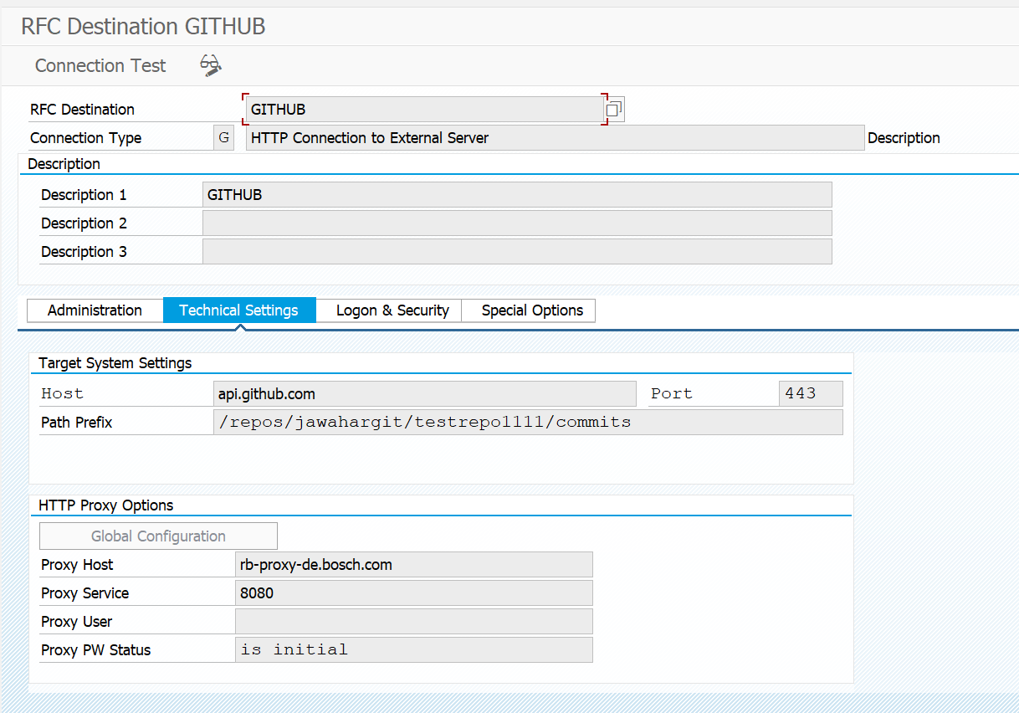

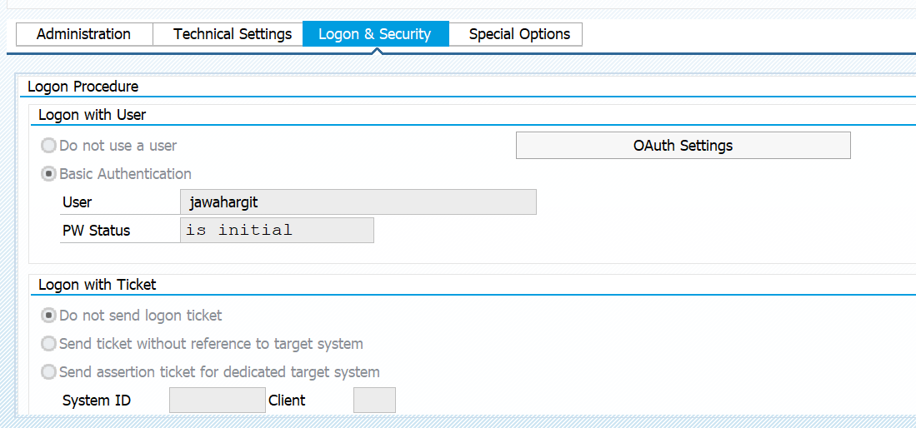

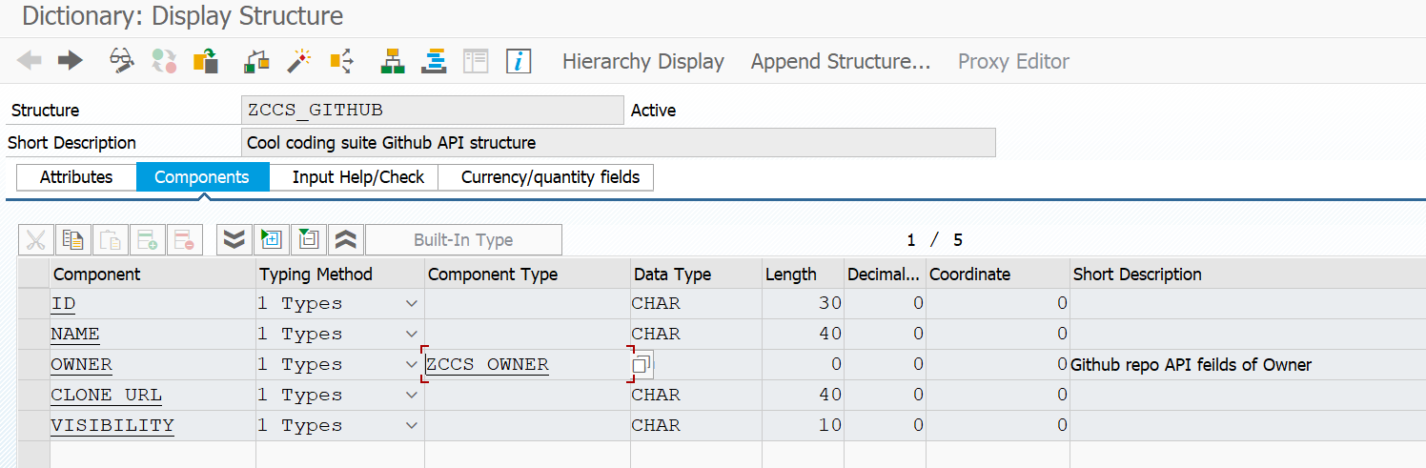

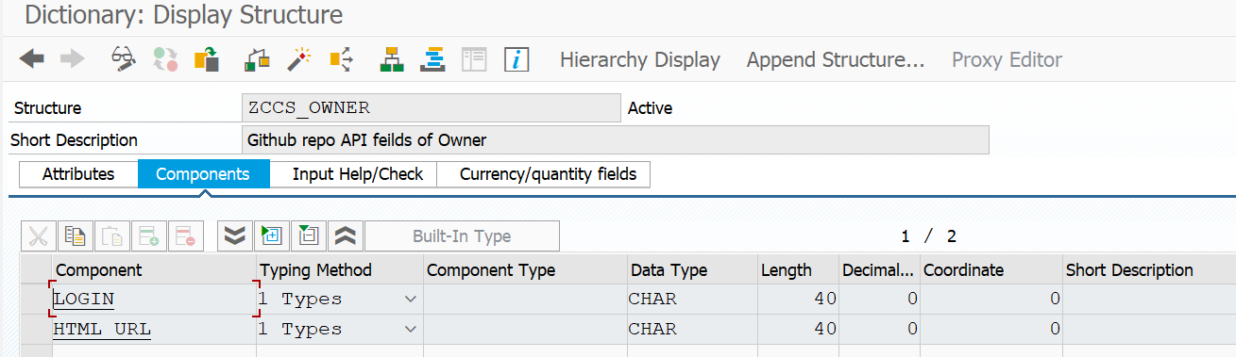

Below enttiy type Gitrepo is created by importing the structure - ZCCS_GITHUB

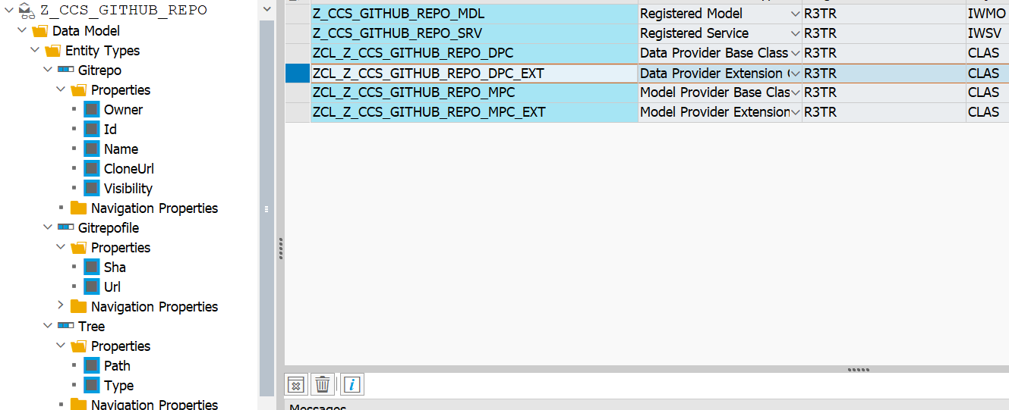

METHOD gitreposet_get_entityset.

*\*\*TRY.*

*\*CALL METHOD SUPER->GITREPOSET_GET_ENTITYSET*

*\*  EXPORTING*

*\*    IV_ENTITY_NAME           =*

*\*    IV_ENTITY_SET_NAME       =*

*\*    IV_SOURCE_NAME           =*

*\*    IT_FILTER_SELECT_OPTIONS =*

*\*    IS_PAGING                =*

*\*    IT_KEY_TAB               =*

*\*    IT_NAVIGATION_PATH       =*

*\*    IT_ORDER                 =*

*\*    IV_FILTER_STRING         =*

*\*    IV_SEARCH_STRING         =*

*\*\*    io_tech_request_context  =*

*\*\*  IMPORTING*

*\*\*    et_entityset             =*

*\*\*    es_response_context      =*

*\*    .*

*\*\*  CATCH /iwbep/cx_mgw_busi_exception.*

*\*\*  CATCH /iwbep/cx_mgw_tech_exception.*

*\*\*ENDTRY.*

*\* Declarations*

    DATA lo_client         TYPE REF TO if_http_client.

    DATA lo_conv           TYPE REF TO cl_abap_conv_in_ce.

    DATA lo_rest_client    TYPE REF TO cl_rest_http_client.

    DATA lo_response       TYPE REF TO if_rest_entity.

    DATA lv_result_url     TYPE string.

    DATA lv_url            TYPE string.

    DATA lv_json           TYPE string.

    DATA lv_response       TYPE string.

    DATA lv_httpcode       TYPE i.

    DATA lv_reason         TYPE string.

    DATA lv_message        TYPE string.

    DATA lv_index          TYPE i.

    DATA lt_gitrepo      TYPE STANDARD TABLE OF ZCCS_GITHUB .

    DATA response          TYPE string.

    CALL METHOD cl_http_client=>create_by_destination

      EXPORTING

        destination              = 'GITHUB'

      IMPORTING

        client                   = lo_client

      EXCEPTIONS

        argument_not_found       = 1

        destination_not_found    = 2

        destination_no_authority = 3

        plugin_not_active        = 4

        internal_error           = 5

        OTHERS                   = 6.

    IF sy-subrc <> 0.

    ENDIF.

    IF lo_client IS BOUND.

*\* Send the HTTP request*

      CALL METHOD lo_client->send

        EXCEPTIONS

          http_communication_failure = 1

          http_invalid_state         = 2

          http_processing_failed     = 3

          http_invalid_timeout       = 4

          OTHERS                     = 5.

      IF sy-subrc <> 0.

      ENDIF.

*\* HTTP call receive*

      CALL METHOD lo_client->receive

        EXCEPTIONS

          http_communication_failure = 1

          http_invalid_state         = 2

          http_processing_failed     = 3

          OTHERS                     = 4.

      IF sy-subrc <> 0.

      ENDIF.

*\*   get status of the response*

      CALL METHOD lo_client->response->get_status

        IMPORTING

          code   = lv_httpcode

          reason = lv_reason.

*\* Instantiate REST client*

      CREATE OBJECT lo_rest_client

        EXPORTING

          io_http_client = lo_client.

*\* Get Response data*

      lo_response = lo_rest_client->if_rest_client~get_response_entity( ).

*\* Get string data*

      lv_json = lo_response->get_string_data( ).

*\* Convert string to Abap structures (*

      CALL METHOD /ui2/cl_json=>deserialize

        EXPORTING

          json        = lv_json

          pretty_name = /ui2/cl_json=>pretty_mode-camel_case

        CHANGING

          data        = lt_gitrepo.

      IF sy-subrc = 0.

        DATA wa_entityset LIKE LINE OF et_entityset.

        LOOP AT lt_gitrepo ASSIGNING FIELD-SYMBOL(<lfs_gitrepo>).

          wa_entityset-id = <lfs_gitrepo>-id.

          wa_entityset-name = <lfs_gitrepo>-name. "repo name

          wa_entityset-owner-login = <lfs_gitrepo>-owner-login.

          wa_entityset-owner-html_url = <lfs_gitrepo>-owner-html_url.

          wa_entityset-clone_url = <lfs_gitrepo>-clone_url.

          wa_entityset-visibility = <lfs_gitrepo>-visibility.

          APPEND wa_entityset TO et_entityset.

          CLEAR: wa_entityset.

        ENDLOOP.

      ENDIF.

    ENDIF.

  ENDMETHOD.

 T46/022 - SEGW : Project name : Z_CCS_GITHUB_FILES

API used -

API to fetch all the folders and files inside folders for a given repository

<https://api.github.com/repos/Devsouravpanda/Sample/git/trees/main?recursive=1>

As we can see the Json repsonse is nested table ( see [ ] in reponse

Always consider [ and ] at end of json string in ABAP

And any [ ] in between those are nested internal tables

Thats why we go 1 -> many and use get expanded entity ( header -> item )

Association , Navigation concepts comes.

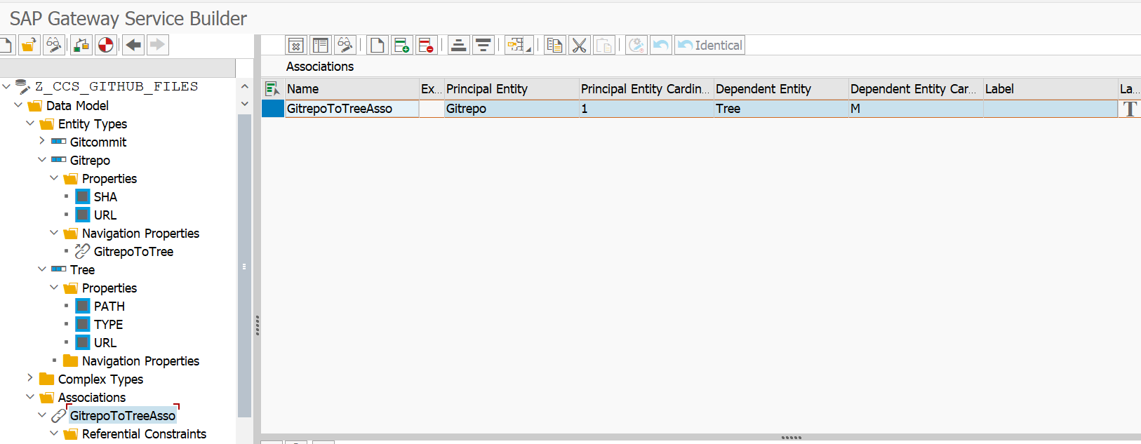

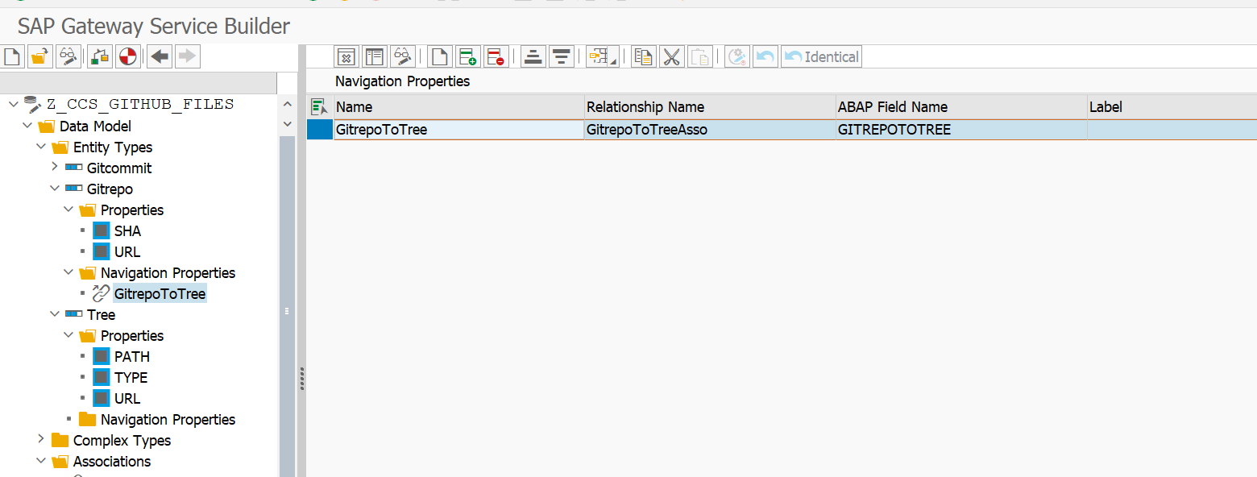

Below structure created in se11 for Tree entity type ( imported the ddic structure)

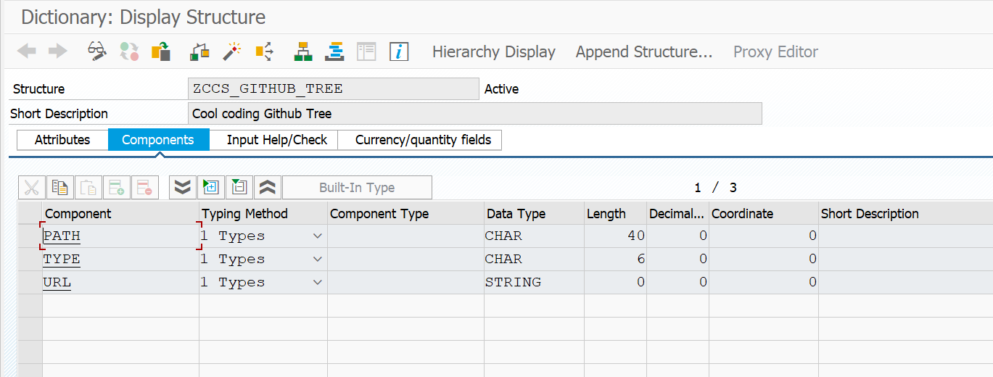

  METHOD /iwbep/if_mgw_appl_srv_runtime~get_expanded_entityset.

*\*\*TRY.*

*\*CALL METHOD SUPER->/IWBEP/IF_MGW_APPL_SRV_RUNTIME~GET_EXPANDED_ENTITYSET*

*\*\*  EXPORTING*

*\*\*    iv_entity_name           =*

*\*\*    iv_entity_set_name       =*

*\*\*    iv_source_name           =*

*\*\*    it_filter_select_options =*

*\*\*    it_order                 =*

*\*\*    is_paging                =*

*\*\*    it_navigation_path       =*

*\*\*    it_key_tab               =*

*\*\*    iv_filter_string         =*

*\*\*    iv_search_string         =*

*\*\*    io_expand                =*

*\*\*    io_tech_request_context  =*

*\*\*  IMPORTING*

*\*\*    er_entityset             =*

*\*\*    et_expanded_clauses      =*

*\*\*    et_expanded_tech_clauses =*

*\*\*    es_response_context      =*

*\*    .*

*\*\*  CATCH /iwbep/cx_mgw_busi_exception.*

*\*\*  CATCH /iwbep/cx_mgw_tech_exception.*

*\*\*ENDTRY.*

    TYPES: tt_github_tree TYPE STANDARD TABLE OF zccs_github_tree WITH DEFAULT KEY.

    TYPES: BEGIN OF ty_gitrepo,

             sha           TYPE char40,

             url           TYPE char40,

             GitrepoToTree TYPE tt_github_tree, *"GitrepoToTree is Navigation name*

           END OF ty_gitrepo.

    TYPES: tt_gitrepo TYPE STANDARD TABLE OF ty_gitrepo WITH DEFAULT KEY.

*"TYPES : tt_github_deep TYPE STANDARD TABLE OF zccs_github_deep WITH DEFAULT KEY.*

*"DATA : it_out_tab  TYPE tt_GITHUB_DEEP.*

*"wa_out_tab  LIKE LINE OF it_out_tab.*

*\* Declarations*

    DATA lo_client         TYPE REF TO if_http_client.

    DATA lo_conv           TYPE REF TO cl_abap_conv_in_ce.

    DATA lo_rest_client    TYPE REF TO cl_rest_http_client.

    DATA lo_response       TYPE REF TO if_rest_entity.

    DATA lv_result_url     TYPE string.

    DATA lv_url            TYPE string.

    DATA lv_json           TYPE string.

    DATA lv_response       TYPE string.

    DATA lv_httpcode       TYPE i.

    DATA lv_reason         TYPE string.

    DATA lv_message        TYPE string.

    DATA lv_index          TYPE i.

    DATA lt_gitrepo        TYPE  tt_gitrepo.

    DATA lwa_final  TYPE ty_gitrepo.

    DATA lt_final TYPE tt_gitrepo .

    DATA lwa_gitrepo TYPE ty_gitrepo.

    DATA response          TYPE string.

    CASE iv_entity_set_name.

      WHEN 'GitrepoSet'.

        CALL METHOD cl_http_client=>create_by_destination

          EXPORTING

            destination              = 'GITHUB'

          IMPORTING

            client                   = lo_client

          EXCEPTIONS

            argument_not_found       = 1

            destination_not_found    = 2

            destination_no_authority = 3

            plugin_not_active        = 4

            internal_error           = 5

            OTHERS                   = 6.

        IF sy-subrc <> 0.

        ENDIF.

        IF lo_client IS BOUND.

*\* Send the HTTP request*

          CALL METHOD lo_client->send

            EXCEPTIONS

              http_communication_failure = 1

              http_invalid_state         = 2

              http_processing_failed     = 3

              http_invalid_timeout       = 4

              OTHERS                     = 5.

          IF sy-subrc <> 0.

          ENDIF.

*\* HTTP call receive*

          CALL METHOD lo_client->receive

            EXCEPTIONS

              http_communication_failure = 1

              http_invalid_state         = 2

              http_processing_failed     = 3

              OTHERS                     = 4.

          IF sy-subrc <> 0.

          ENDIF.

          lv_url = lo_client->path_prefix.

          REPLACE ALL OCCURRENCES OF 'repos/' IN lv_url  WITH ' '.

          CONDENSE lv_url.

          REPLACE ALL OCCURRENCES OF 'git/trees/main?recursive=1' IN lv_url  WITH ' '.

          CONDENSE lv_url.

          lv_url = '<https://github.com>' && lv_url.

*\*   get status of the response*

          CALL METHOD lo_client->response->get_status

            IMPORTING

              code   = lv_httpcode

              reason = lv_reason.

*\* Instantiate REST client*

          CREATE OBJECT lo_rest_client

            EXPORTING

              io_http_client = lo_client.

*\* Get Response data*

          lo_response = lo_rest_client->if_rest_client~get_response_entity( ).

*\* Get string data*

          lv_json = lo_response->get_string_data( ).

          REPLACE ALL OCCURRENCES OF '"tree"' IN lv_json WITH '"GitrepoToTree"'.

*"REPLACE ALL OCCURRENCES OF '"Gitrep"' IN lv_json WITH '"tree"'.*

          lv_json = '[' && lv_json && ']' .

*\* Convert string to Abap structures (*

          CALL METHOD /ui2/cl_json=>deserialize

            EXPORTING

              json        = lv_json

              pretty_name = /ui2/cl_json=>pretty_mode-camel_case

            CHANGING

              data        = lt_gitrepo.

          LOOP AT lt_gitrepo ASSIGNING FIELD-SYMBOL(<lfs_gitrepo>).

*\* PROCESS the second level internal table.*

            LOOP AT <lfs_gitrepo>-GitrepoToTree

              ASSIGNING FIELD-SYMBOL(<lfs_gittree>).

              IF sy-subrc = 0.

                if <lfs_gittree>-type ne 'blob'.

                  <lfs_gittree>-type = 'tree'.

                  endif.

                <lfs_gittree>-url = lv_url && <lfs_gittree>-type && '/main/' && <lfs_gittree>-path .

              ENDIF.

            ENDLOOP.

          ENDLOOP.

*"MOVE-CORRESPONDING lt_gitrepo-tree to GitrepoToTree.*

*"MOVE-CORRESPONDING lt_gitrepo-tree TO er_entityset-GitrepoToTree.*

          copy_data_to_ref(

        EXPORTING

         is_data = lt_gitrepo

        CHANGING

         cr_data = er_entityset ).

        ENDIF.

    ENDCASE.

  ENDMETHOD.

Debug mode screenshots:

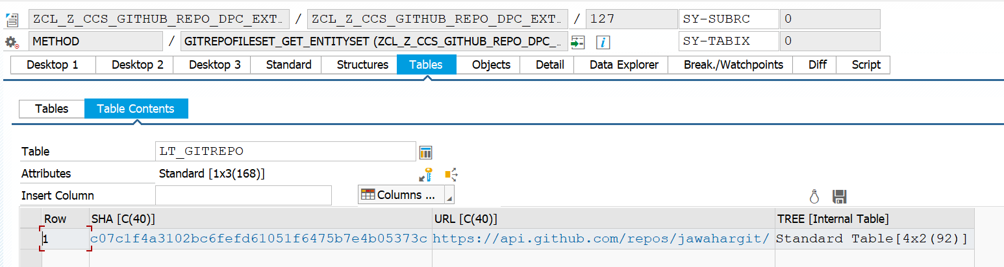

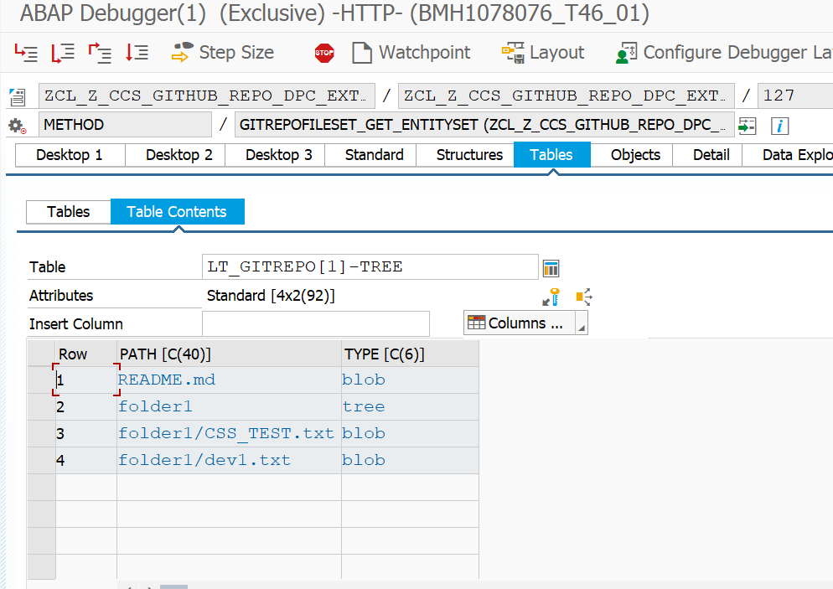

T46/022 - SEGW : Project name : Z_CCS_GITHUB_FILES

API to fetch latest commit date for a given file/ folder

API used : <https://api.github.com/repos/jawahargit/testrepo1111/commits?path=Python>

Structures created in se11

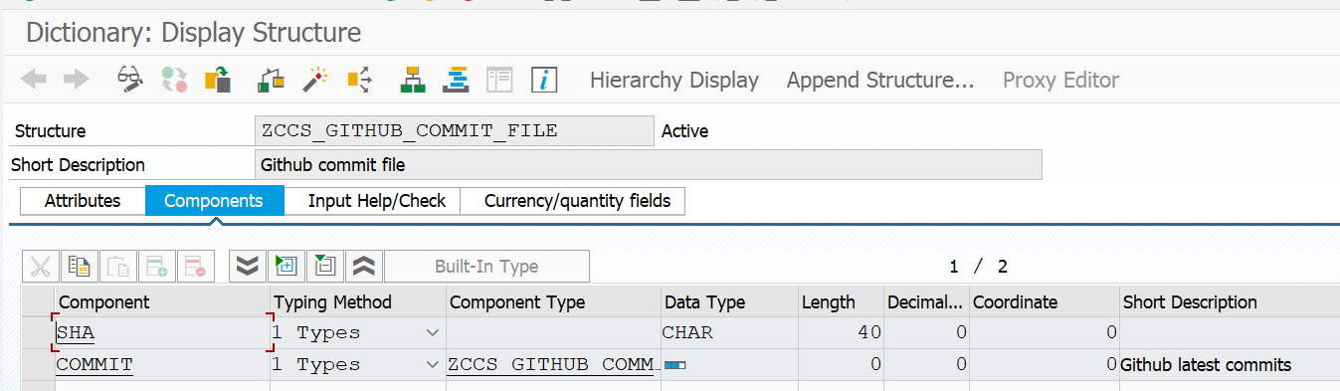

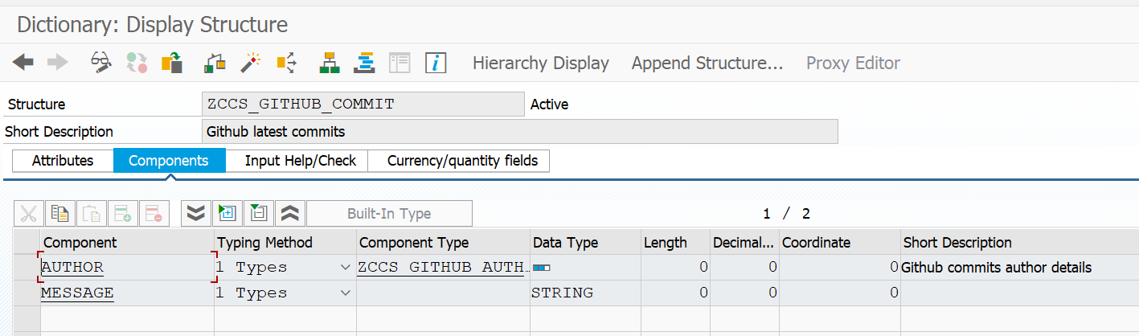

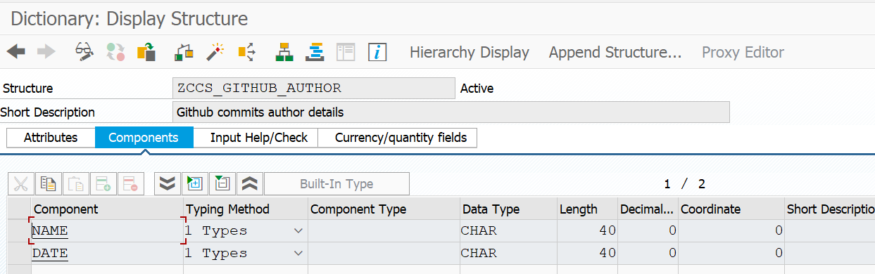

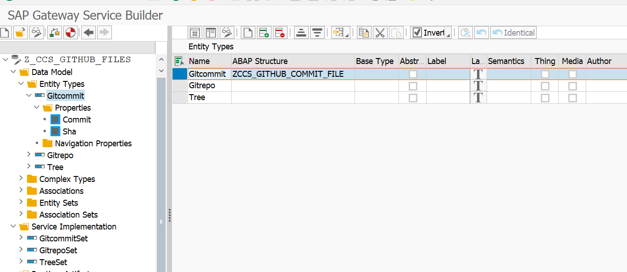

  METHOD gitcommitset_get_entityset.

*\*\*TRY.*

*\*CALL METHOD SUPER->GITCOMMITSET_GET_ENTITYSET*

*\*  EXPORTING*

*\*    IV_ENTITY_NAME           =*

*\*    IV_ENTITY_SET_NAME       =*

*\*    IV_SOURCE_NAME           =*

*\*    IT_FILTER_SELECT_OPTIONS =*

*\*    IS_PAGING                =*

*\*    IT_KEY_TAB               =*

*\*    IT_NAVIGATION_PATH       =*

*\*    IT_ORDER                 =*

*\*    IV_FILTER_STRING         =*

*\*    IV_SEARCH_STRING         =*

*\*\*    io_tech_request_context  =*

*\*\*  IMPORTING*

*\*\*    et_entityset             =*

*\*\*    es_response_context      =*

*\*    .*

*\*\*  CATCH /iwbep/cx_mgw_busi_exception.*

*\*\*  CATCH /iwbep/cx_mgw_tech_exception.*

*\*\*ENDTRY.*

*\* Declarations*

    DATA lo_client         TYPE REF TO if_http_client.

    DATA lo_conv           TYPE REF TO cl_abap_conv_in_ce.

    DATA lo_rest_client    TYPE REF TO cl_rest_http_client.

    DATA lo_response       TYPE REF TO if_rest_entity.

    DATA lv_result_url     TYPE string.

    DATA lv_url            TYPE string.

    DATA lv_json           TYPE string.

    DATA lv_response       TYPE string.

    DATA lv_httpcode       TYPE i.

    DATA lv_reason         TYPE string.

    DATA lv_message        TYPE string.

    DATA lv_index          TYPE i.

    DATA lt_git_commit_file      TYPE STANDARD TABLE OF zccs_github_commit_file .

    DATA response          TYPE string.

    CALL METHOD cl_http_client=>create_by_destination

      EXPORTING

        destination              = 'GITHUB'

      IMPORTING

        client                   = lo_client

      EXCEPTIONS

        argument_not_found       = 1

        destination_not_found    = 2

        destination_no_authority = 3

        plugin_not_active        = 4

        internal_error           = 5

        OTHERS                   = 6.

    IF sy-subrc <> 0.

    ENDIF.

    IF lo_client IS BOUND.

*\* Send the HTTP request*

      CALL METHOD lo_client->send

        EXCEPTIONS

          http_communication_failure = 1

          http_invalid_state         = 2

          http_processing_failed     = 3

          http_invalid_timeout       = 4

          OTHERS                     = 5.

      IF sy-subrc <> 0.

      ENDIF.

*\* HTTP call receive*

      CALL METHOD lo_client->receive

        EXCEPTIONS

          http_communication_failure = 1

          http_invalid_state         = 2

          http_processing_failed     = 3

          OTHERS                     = 4.

      IF sy-subrc <> 0.

      ENDIF.

*\*   get status of the response*

      CALL METHOD lo_client->response->get_status

        IMPORTING

          code   = lv_httpcode

          reason = lv_reason.

*\* Instantiate REST client*

      CREATE OBJECT lo_rest_client

        EXPORTING

          io_http_client = lo_client.

*\* Get Response data*

      lo_response = lo_rest_client->if_rest_client~get_response_entity( ).

*\* Get string data*

      lv_json = lo_response->get_string_data( ).

*\* Convert string to Abap structures (*

      CALL METHOD /ui2/cl_json=>deserialize

        EXPORTING

          json        = lv_json

          pretty_name = /ui2/cl_json=>pretty_mode-camel_case

        CHANGING

          data        = lt_git_commit_file.

      IF sy-subrc = 0.

        DATA wa_entityset LIKE LINE OF et_entityset.

        LOOP AT lt_git_commit_file ASSIGNING FIELD-SYMBOL(<lfs_gitrepo>).

          wa_entityset-sha = <lfs_gitrepo>-sha.

          wa_entityset-commit-author-name = <lfs_gitrepo>-commit-author-name.

          wa_entityset-commit-author-date = <lfs_gitrepo>-commit-author-date.

          REPLACE ALL OCCURRENCES OF 'Create' IN <lfs_gitrepo>-commit-message

          WITH space.

          CONDENSE <lfs_gitrepo>-commit-message NO-GAPS.

          wa_entityset-commit-message = <lfs_gitrepo>-commit-message.

          APPEND wa_entityset TO et_entityset.

          CLEAR: wa_entityset.

        ENDLOOP.

      ENDIF.

    ENDIF.

  ENDMETHOD.